ASSIGNMENT-2

Name-Sumit Kumar

Reg-19BIT0075

SHUTTLE SUMIT

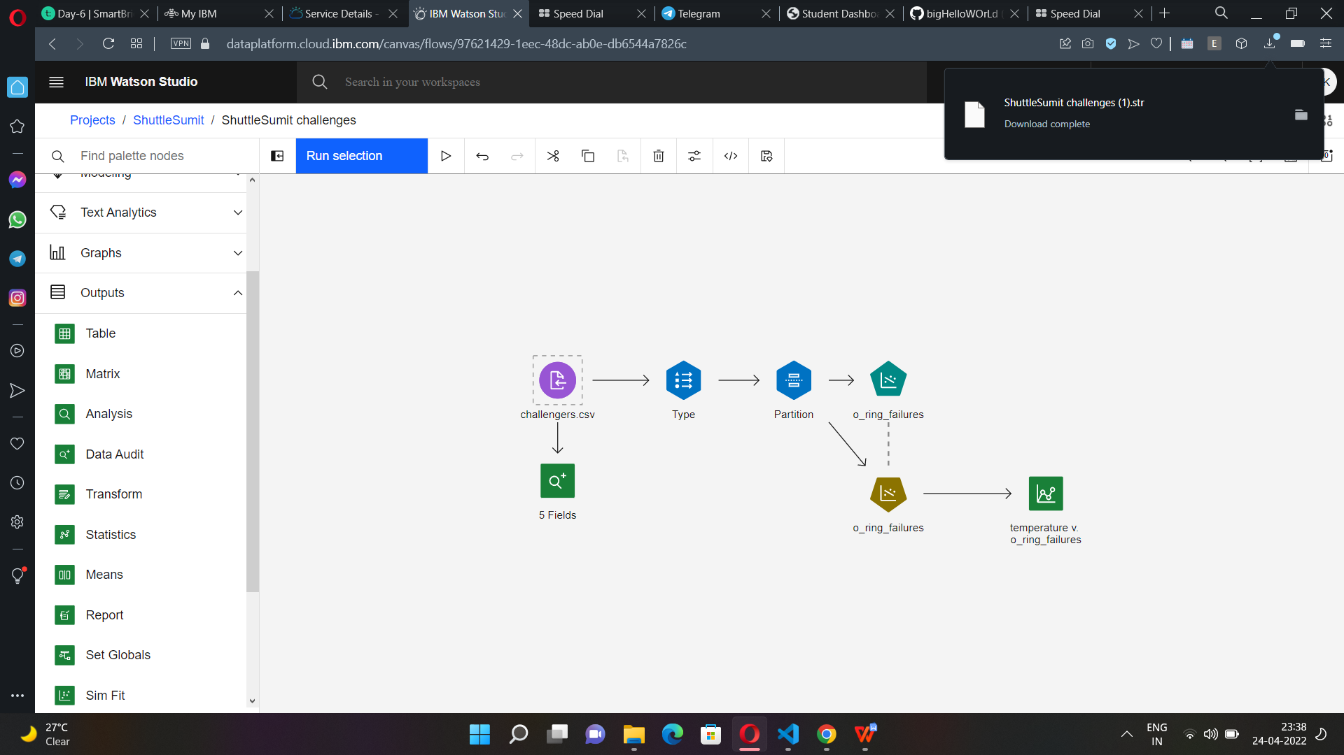

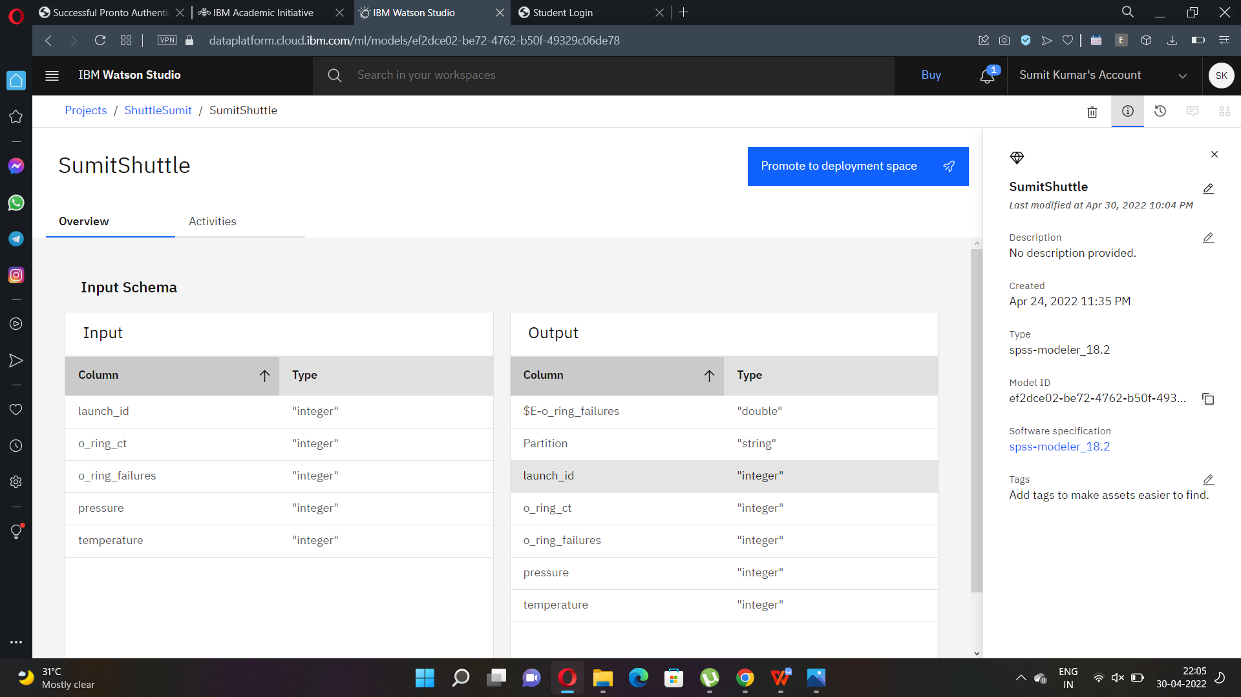

Extra assignment on Diabates:

